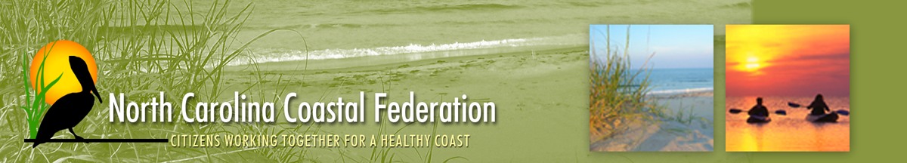

FOR IMMEDIATE RELEASE Feb. 25, 2013

Contact: Sarah Phillips
Phone: 252.393.8185
Email: sarahp@nccoast.org

Oyster Roast Celebrates Federation Oyster Restoration Work

OCEAN – Restoring oysters in North Carolina means you get to eat them. Join the N.C. Coastal Federation to celebrate their oyster restoration successes with an oyster roast at Hannah’s Haus in Beaufort on Thursday, March 7, beginning at 5 p.m.

Habitat restoration helps repopulate our native oyster population, which is important for many reasons. Oysters are great filter feeders, thereby helping to keep coastal waters cleaner. Oysters are also great habitat for fish and other shellfish. Federation staff will talk about all this at the roast, about the importance of local projects and how volunteers can help. You can join the federation at roast for the special, reduced price of $15.

Local bluegrass band Gumbo Lily will play during the two-hour event, promising a good time.

There is no cost for this event, but oyster and beer donations will go directly to the federation.

